**NATIONAL ACADEMY OF SCIENCE AND TECHNOLOGY**



A Project Report On

**MODERN PERIODIC TABLE, ITS MERITS,**

**AND DEMERITS**



Submitted To: Submitted By:

Mr. D.B Khadka Amrit Pant

Class 11 (2022)

Section F

**ACKNOWLEDGEMENT**

I want to express my special Gratitude to **Mr. D.B Khadka sir** who gave me this opportunity to present a report on the **MODERN PERIODIC TABLE, ITS MERITS, AND DEMERITS**. I want to extend my gratitude to my parents who supported and motivated me while doing the Project. I want to thank my friends Ritik Chand, Prasab Kunwar, and Ashish Chand who helped me to finish this report within a limited time. I have also taken some references from websites that are mentioned at last page.

THANKS TO THE EVERYBODY WHO HELPED ME WITH THIS PRO**J**ECT

Amrit Pant

**Certificate of Completion**

This is to certify that this Project is made by **Amrit Pant** a student of **Class 11 (Section F).** From the **National Academy of Science and Technology** on the topic of **MODERN PERIODIC TABLE, ITS MERITS, AND DEMERITS.** Under the guidance of **Mr. D.B Khadka**  and have been completed.

**Mr. DB Khadka Mr. Krishna Bhandari**

**Lecturer of Chemistry HOD, Science**

**Mr. Upendra Bahadur Bam**

**Principle**

**Table of Contents**

1. What is a Periodic Table and why do we need one ……...5
2. History of Periodic Table …….………………………………6
3. Mendeleev’s Periodic table……………..……………………7
4. The Modern Periodic Table……………...…………………...9
5. References …………………..………………………………..11

## **Introduction**

## The periodic table is an important tool for scientists to understand the elements and their properties. It is used by chemists, physicists, and other scientists in a variety of fields. In this post, we will explore why the periodic table is so important and why it is still relevant today.

## **The Basics of the Periodic Table**

## The periodic table is a chart that organizes elements according to their atomic number, electron configuration, and recurring chemical properties. It is a powerful tool for understanding the elements and how they interact with each other. It also allows us to predict the properties of elements that have yet to be discovered.

## **The Importance of the Periodic Table**

The periodic table is essential for understanding the behavior of different elements and their interactions with each other. It provides a framework for understanding the properties of elements and their reactivity. It also helps us make predictions about the properties of new elements, which can be useful in research and development.

**Dobnier’s Triade**

In 1817, Johann Wolfgang Dobereiner observed that elements could be grouped into sets of three, with the middle element having an atomic weight approximately midway between the weights of the other two elements. This phenomenon became known as Dobereiner's Triads.

**Newland’s Law of Octave**

Newland's Law of Octave states that when elements of the periodic table are arranged in order of increasing atomic weight, every eighth element has similar chemical and physical properties. This law was proposed by John Newlands in 1864, making it one of the earliest attempts to arrange the elements according to their atomic weights.

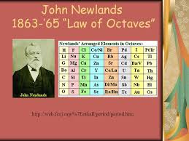T

**Introduction Mendeleev's Periodic Table**

It is one of the most important scientific discoveries of the 19th century. It is a tabular arrangement of elements based on their atomic structure and properties.

**Discovery**

In 1869, Dmitri Mendeleev published the first version of his Periodic Table. He arranged the elements in order of increasing atomic mass and noticed that when he did so, certain elements would fall into regular patterns. This led him to realize that elements with similar chemical properties had similar atomic masses.

## **Organization**

The Periodic Table is organized into groups and periods. Groups are composed of elements with similar properties, while periods are composed of elements with similar atomic structures. Each element is further identified by its atomic number, which is the number of protons in its nucleus.

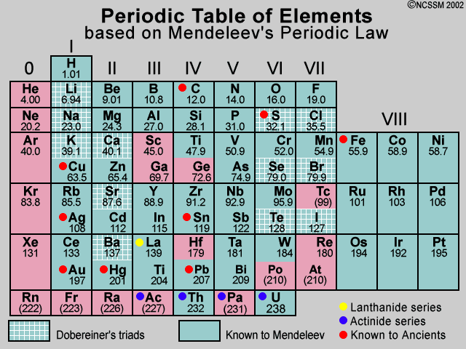

## **Advantages of Mendeleev’s Periodic Table**

1. It arranges elements in the order of their atomic numbers and provides a systematic way of representing them.
2. It is easy to learn and understand, making it a great educational tool for students.
3. It allows for the prediction of properties based on the position of elements in the table.
4. It provides a visual representation of the elements and their relationships.
5. It can be used to predict the properties of unknown elements.

## **Disadvantages of Mendeleev’s Periodic table**

1. It does not account for some of the new elements discovered since Mendeleev developed it.
2. It does not consider the effects of isotopes on the properties of elements.
3. It does not adequately represent certain properties of elements, such as electronegativity.
4. It does not accurately reflect the exact arrangement of electrons in atoms.
5. It cannot predict the properties of elements that do not fit into the table.

## **Introduction**

The modern periodic table is a representation of the elements that are essential for life. This organization of the elements helps chemists to understand and predict the behavior of different elements. It is an invaluable tool for scientists and students alike.

## **History**

The modern periodic table was first proposed by Henery Moseley in 1913. Moseley realized that certain elements had similar characteristics and that they could be arranged into a table according to their atomic Number.

**Elements**

The modern periodic table is composed of 118 elements arranged in 18 columns and seven rows. Each element is labeled with its atomic number, symbol, and atomic weight. Elements in the same column tend to have similar properties, such as reactivity, electronegativity, and boiling point.

## 

## **Advantages of Modern Periodic Table**

* Helps to organize the elements according to their atomic structure.
* The structure allows for easier identification and comparison of elements.
* Makes it easier to predict the properties of elements.
* Allows for the categorization of elements into groups with similar properties.
* Can be used to predict and explain chemical reactions.

## **Disadvantages of Modern Periodic Table**

* Position of Hydrogen gas it shows properties both like alkaline earth metals and Halogens
* There is a separate position of Lathinides and Actnides without proper reason.
* Limitations in the number of elements that can be included in the table.
* Does not provide much information on the physical properties of elements.
* Does not provide information on the effects of different elements on each other.

**References:**

[*https://www.google.com*](https://www.google.com)

[*https://www.youtube.com*](https://www.youtube.com)

[*https://wikipedia.org*](https://wikipedia.org)

[*https://notion.so/ai*](https://notion.so/ai)